ELEC 374 – Digital Systems Engineering

Lab 1 Report

Divaydeep Singh, 20143859

Lucas Austin, 20061953

ALU

BUS

BUS Encoder

BUS Multiplexer

General Register

DataPath

Datapath Testbench

MDR register

Multiplication Algorithm

PC Reg

Rotate Register

Z_Register

Waveform Part 3a



Waveform Part 3b



Waveform Part 3c



Waveform Part 3d



Waveform Part 3e

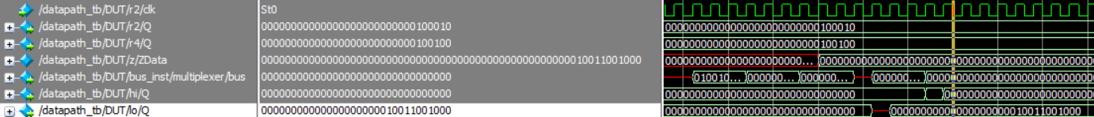

Waveform Part 3f

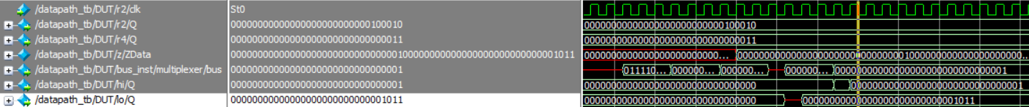

Waveform Part 3g



Waveform Part 3h



Waveform Part 3i



Waveform Part 3j



Waveform Part 3k



Waveform Part 3l

